**홈 환경에서 자율주행 로봇을 이용한 상황 인지**

목표 시나리오: 출퇴근 여부와 부엌의 설겆이를 인지

관련 분야: 상황 인식 컴퓨팅 , 지능형 로봇, Image Captioning, Human Action Recognition

[The KIT Robo-Kitchen Data set for the Evaluation of View-based Activity Recognition Systems](https://isas.iar.kit.edu/pdf/Humanoids11_Rybok.pdf), Rybok et.al., Humanoids 2011, 2011.

* Video data (10 s~4 min)

* 17 different subjects of different age, gender, cultural background, and household skills

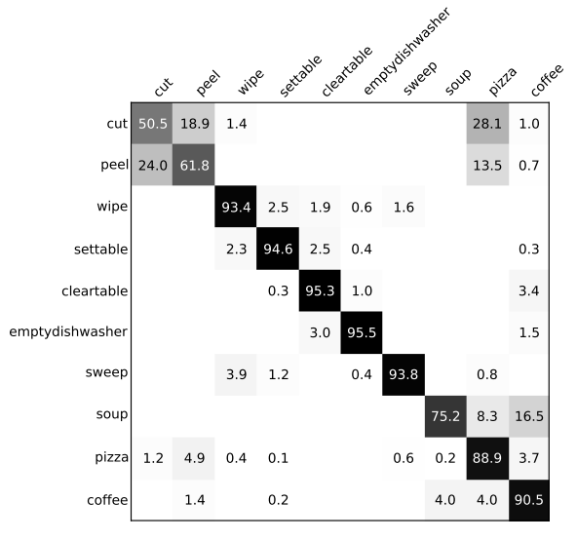

[A Deep Neural Architecture for Kitchen Activity Recognition](https://pdfs.semanticscholar.org/cbdd/4f611f5840b70fcbb5d36e1ea2cc237e59ff.pdf?_ga=2.136625904.1796248851.1575528478-179055882.1570780735), 2017,

* KSCGR (Kitchen Scene Context based Gesture Recognition) Dataset, Challenge in ICPR 2012

- 5 menus (ham and eggs, omelet, scrambled egg, boiled egg, kinshi-tamago) done by 7 subjects

- 8 cooking gestures: breaking, mixing, baking, turning, cutting, boiling, seasoning, peeling, none,

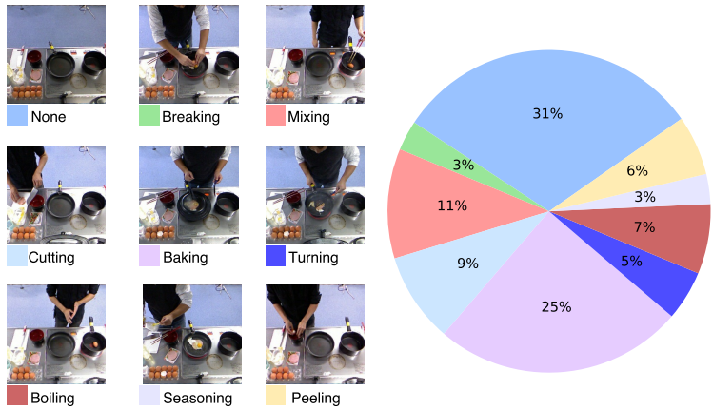

[A Survey of Vision-Based Human Action Evaluation Methods](https://arxiv.org/pdf/1806.11230), Lei et.al., 2019.

* Healthcare and rehabilitation, skill training, sports activity scoring,

[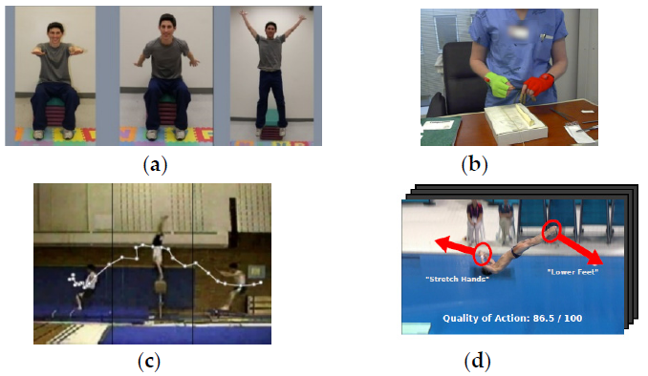Human Action Recognition and Prediction:A Survey](https://arxiv.org/pdf/1806.11230.pdf), Kong and Fu, 2018.

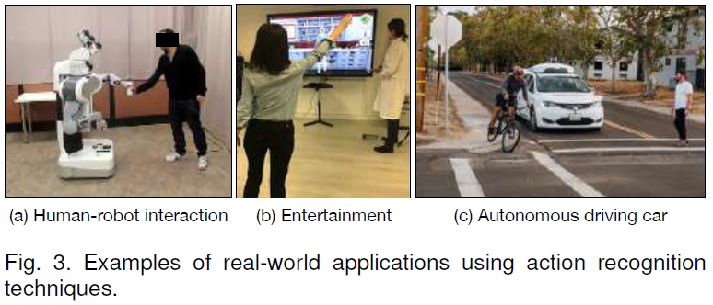

Human Activity Recognition in Smart Home With Deep Learning Approach, 2019.

* healthcare and security of smart homes

* DMLSmartActions Datasets

A Survey of Deep Learning-Based Human Activity Recognition in Radar

1999 Robots in Human Environments

2010 A Survey on Vision-based Human Action Recognition

2015 Advances in Human Action Recognition: A Survey

2018 Human Action Recognition and Prediction: A Survey

2019 A Survey of Vision-Based Human Action Evaluation Methods